**Production Log**

What it means

Rigidbody – A rigidbody is simply an item that has physics.

Variable – A variable is just a name for something that stores some data.

Function – A function is like a package for code which then returns a value.

I started the project with bens movement script which was very basic, you can move up, down, left and right. There was no gravity and it didn’t feel good. 

Attached is a Gif of the movement.

So, with this movement given, my first course of action was to add colliders, a rigid body and change the movement. I removed the vertical movement at will, and just added a physics based jump. It applies force onto the rigid body.

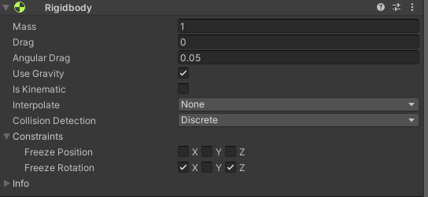

This is what the Rigidbody actually looks like settings wise, it’s restricted on the X and Z axis for rotation as it will never do that, so it just eliminates any possible issues.

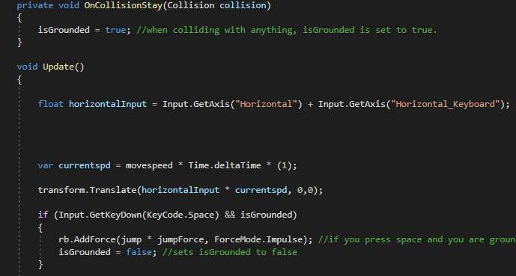

This is the script for movement and jumping. It’s quite simple and can is also quite versatile. I’ve used it since then as well. I used the same code type for the dashing which I then added. It also applies a force on either side of the character which sends them to that side, it also needs to have been one second since you last dashed.



This is a showcase of the player movement after my changes.

My next thing to do was make the platforms that move, this was at the time, deemed to be an important factor in my game, since then it hasn’t been as important but the point stands.

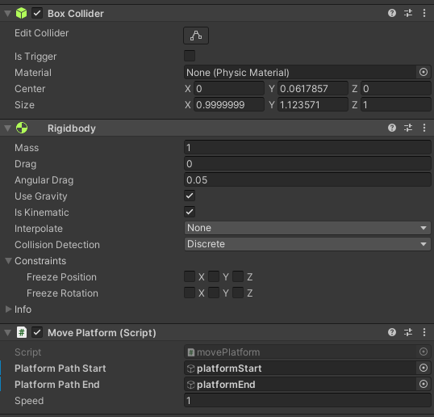

This is the editor display for the moving platform. The code is quite simple as well.

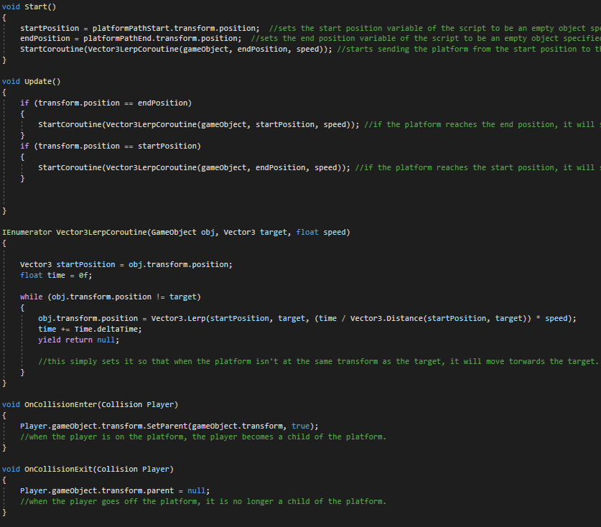

The code shown above is quite simple, when its started, it sets the transforms correctly, and then starts the Vector3LerpCoroutine. A Coroutine is effectively a function that can be stopped before it returns a value. The update function, which runs every frame, simply checks if the platform is at the start or the end positions, when it reaches the start, it moves towards the end position, and vice versa.

When it collides with the player, the player becomes a child object of the platform, and when it stops colliding, it becomes its own parent.



Note the hierarchy on the left hand side, showing the player becoming a child of the platform, and then when I jump, I move independently.

After this, I added the jump pad which is similar to the dashing in terms of how it works. When the player collides with it, it exerts a force onto the player that sends them in a certain direction as specified by the type of script attached.



This is a GIF of the jump pads.

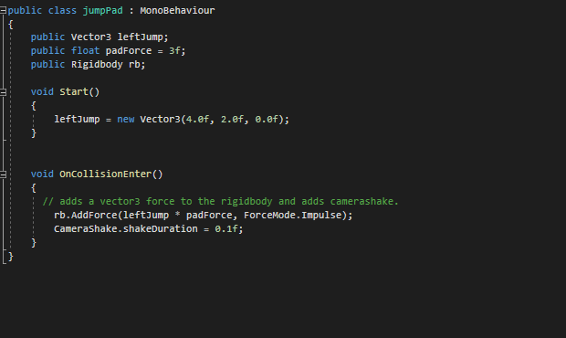

This is the script, showing how similar it is to the dashing and jumping, just instead it now sends you both up and to a direction and when you collide with the object.

Next was the rotation.

The rotation was a very daunting task for me at the start, with me thinking it would be very hard.

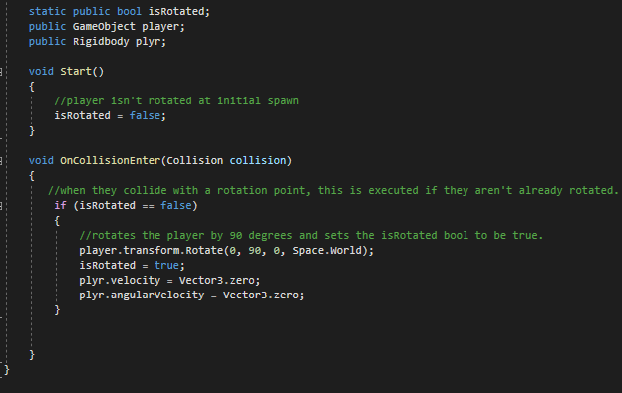

This is all the rotation script, it gets interacted with by others, as the isRotated was quite a major variable that can mess up the game when it’s not set correctly. The plyr.velocity and plyr.angularVelocity is just setting it so that all momentum is cancelled. Here is an example of it working. 

The transition can be jarring, but we’re getting graded on the coding, so I didn’t really need to focus on animation.

The last vital game mechanic is teleportation. I once again found it quite daunting to do this but I don’t think it was that hard in the end.

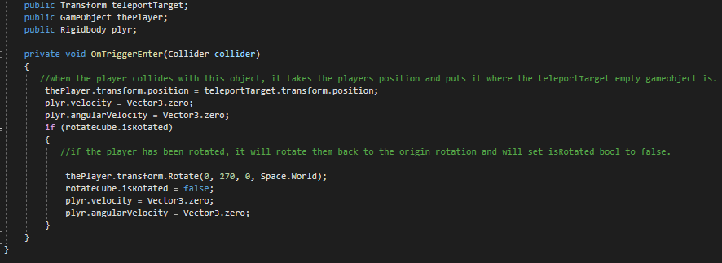

This is the code needed. It simply grabs the players position, and then sets it as the desired position, also cancelling out the momentum in the same way as the rotation. If you are rotated, it will also rotate you back to normal.



This is an example of the teleportation along with me walking back to it.

And that wraps up all the main and vital game mechanics!

After this, I had time left, so decided to add an extra mode! The endless mode.

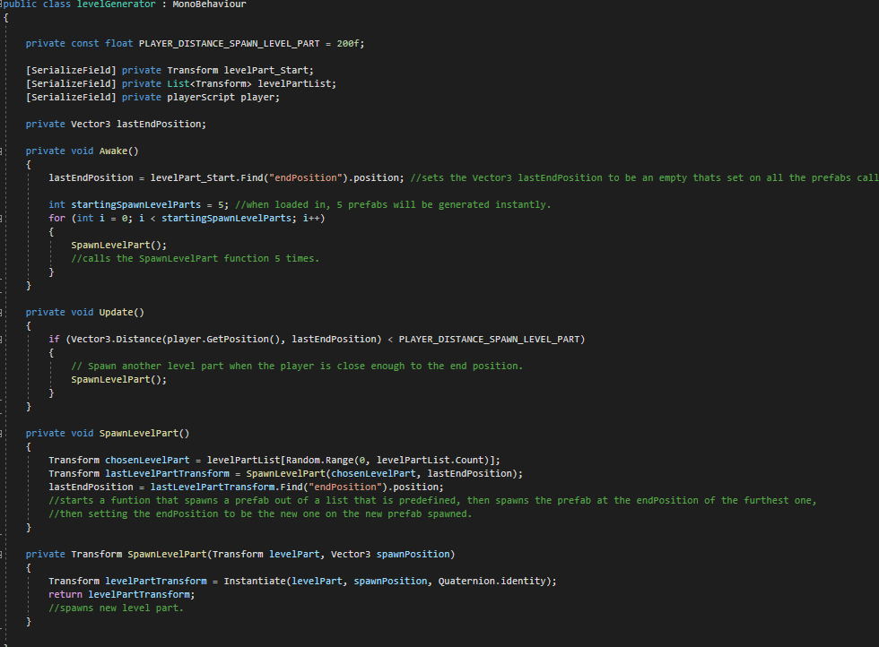

This is the level generator that runs the endless mode, it spawns in 5 level parts to begin with, then when you get close enough to the end of the last level part spawned in, it spawns another. It randomizes which prefab is spawned from the list, and resets the end position. It instantiates at the end position of the last one.



This is a demonstration of how it works, spawning more in the further you go.